BICYCLE RIDES NORTHWEST, INC.
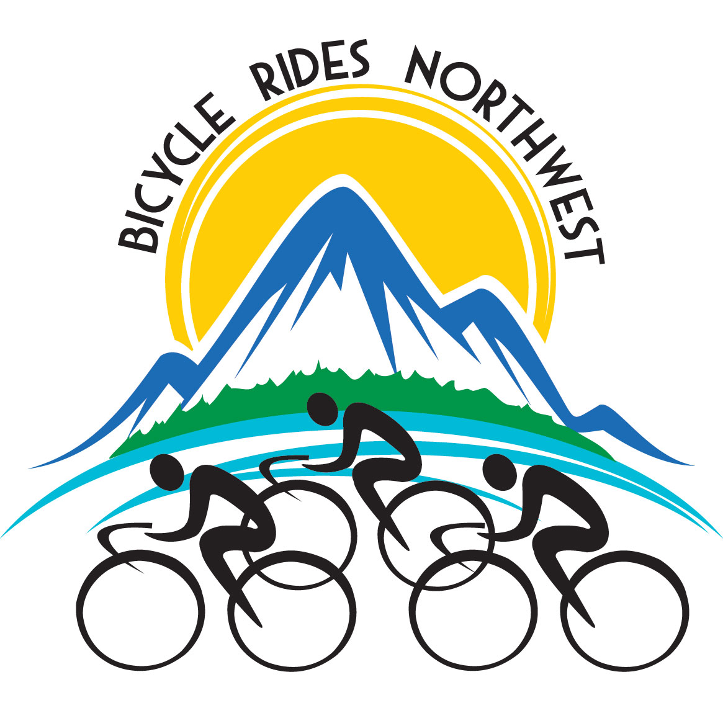
5725 NE Cleveland Ave. ◦ Portland, OR 97211
503.281.1526 ◦ Cell 503.504.2656 ◦ www.bicycleridesnw.org

Large Road Bicycle Tour Coming to Columbus

Bicycle Rides Northwest bringing 300 riders to town as part of June 17-24 tour
Bend, OR, May 13, 2023 – Nonprofit tour operator Bicycle Rides Northwest, based in Bend, Oregon, is bringing a large-scale, fully supported road-bicycle tour that will start and finish in Columbus, arriving Saturday, June 17, staying overnight at Columbus High School and the adjacent City Park and returning on Saturday, June 24.
The event brings up to 300 riders on each tour, accompanied by roughly 60 crew members and vendors. The Montana 2023 tour includes overnight stays in Columbus, Red Lodge, Cooke City (2 nights), Cody (2 nights) and Belfry. The tour brings along its own caterer, shower truck, portable toilets, baggage trucks, bike mechanics and more.
Riders will arrive in Columbus the afternoon of Saturday 6/17, and depart for Red Lodge via Highway 78 between 7 and 8 a.m. the next morning. They will return via Joliet Road mid-day on Saturday 6/24. Cyclists ride at their own pace, so the total group spreads out over the day. The tour operators position signage warning drivers of the event in places where they’re likely to encounter the riders, and the tour has five on-route support vehicles with signs and flashing lights. Riders are required to follow the rules of the road, and the event will not require any traffic control. The organization emphasizes being good visitors to towns along the route.
“We love taking our riders to the most beautiful places in the Northwest,” says BRNW Executive Director Jim Moore. “A big part of that is seeing new places and meeting new people. We want our riders to be respectful of local residents and businesses, and convey that cyclists are a positive presence in town and on the road. We find letting people in each town know we’re coming makes a better experience for everyone, because it’s not a surprise to see hundreds of riders strung out along a road.”
BRNW has been leading tours for more than 35 years, with routes in Oregon, Washington, California, Idaho, Montana and Wyoming. Each year’s two tours are on new routes, with the goal of visiting as many towns and scenic destinations as possible. The organization pays communities and organizations site fees, offers fundraising opportunities for local teams and groups, sources food and supplies from local businesses, and provides host communities with grants each year to apply to whatever project or use will most benefit.

About BRNW
BRNW’s mission is to provide fully supported bicycle tours that deliver an exceptional rider experience, showcase the natural beauty of the Northwest, and benefit communities and businesses in the region. The organization has been operating tours since 1987, currently rotating between routes originating in Oregon, Washington, California, Idaho and Montana. BRNW is a 501(c)(7) nonprofit run by a volunteer board of directors.

##

